**UNIX PROJECT**

**UNIX SHELL PROGRAMMING**

**Name - Sweta Singh**

**Roll No. – 20075091**

**Branch – Computer Science and Engineering**

**MAIN MENU in novice mode**

**1 -- FILE AND MANAGEMENT MENU**

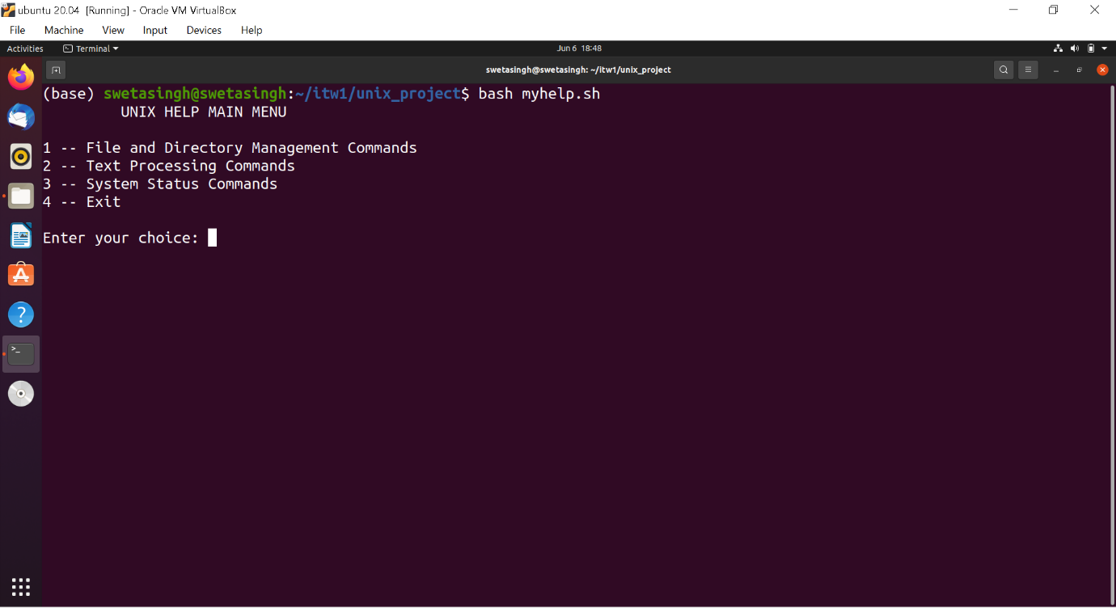

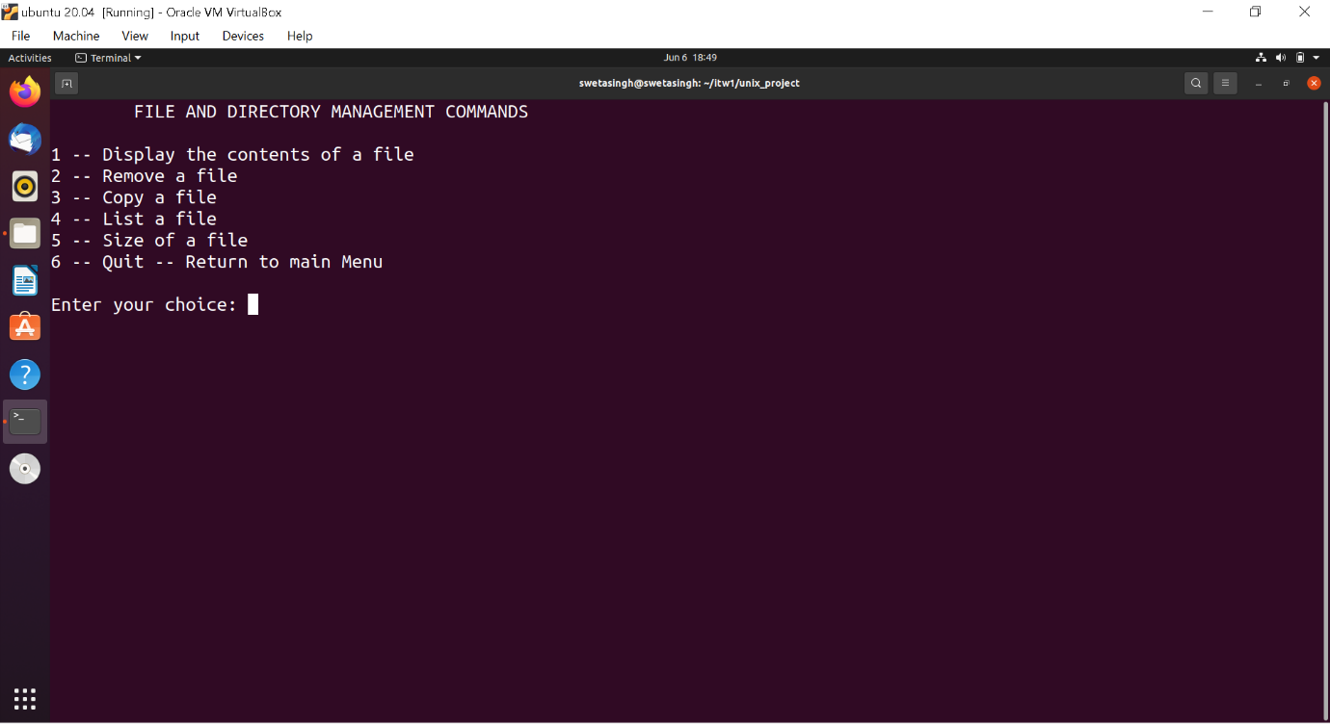

FILE AND MANAGEMENT MENU: 1 -- Display the contents of file

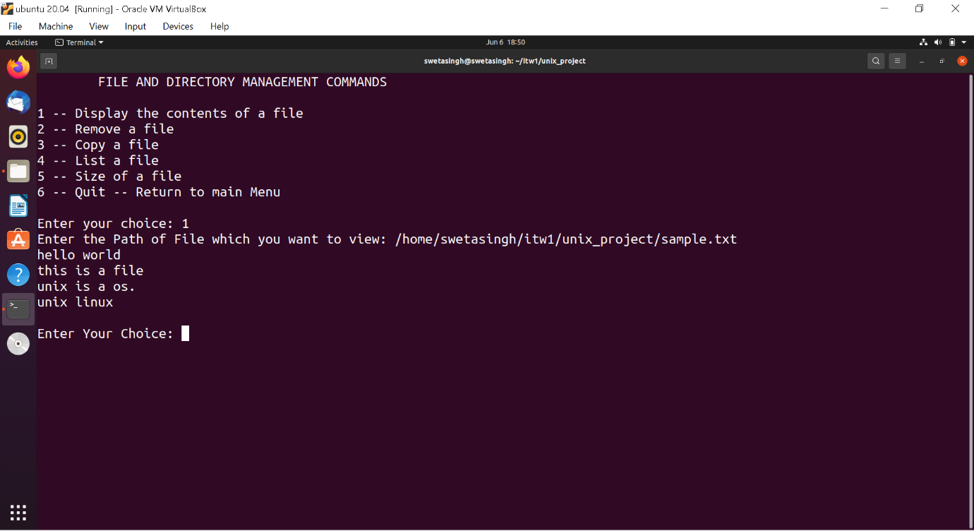

FILE AND MANAGEMENT MENU: 2 – Remove a file

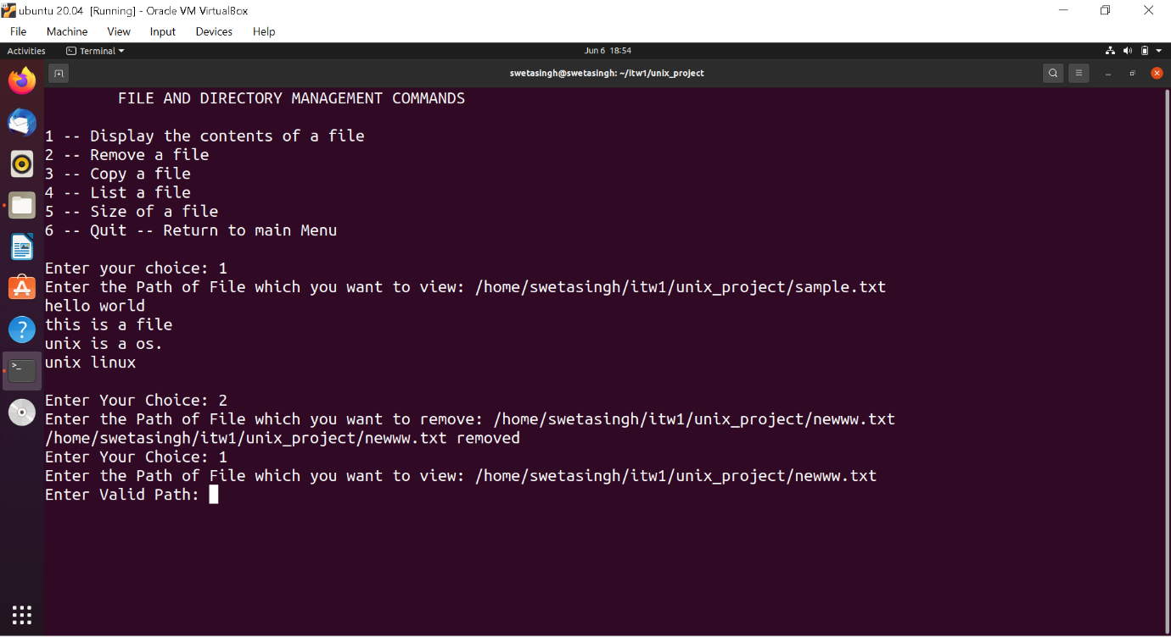

FILE AND MANAGEMENT MENU: 3 – Copy a file

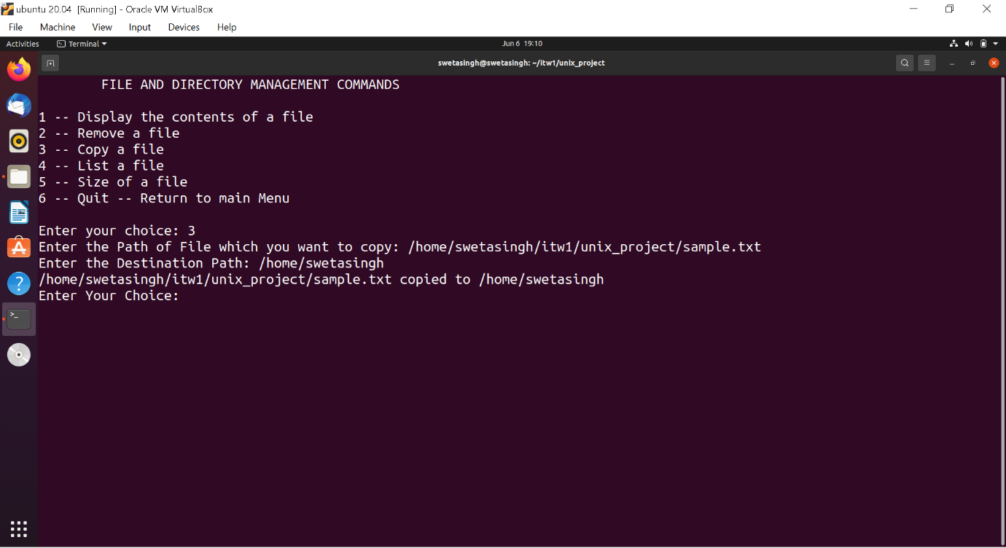

FILE AND MANAGEMENT MENU: 4 – List a file

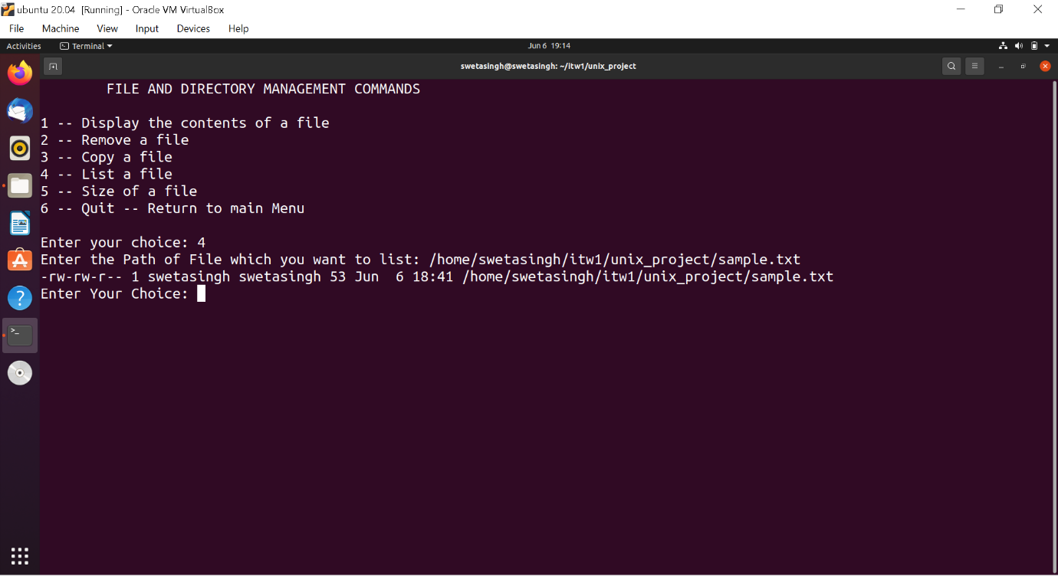

FILE AND MANAGEMENT MENU: 5 – Size of a file

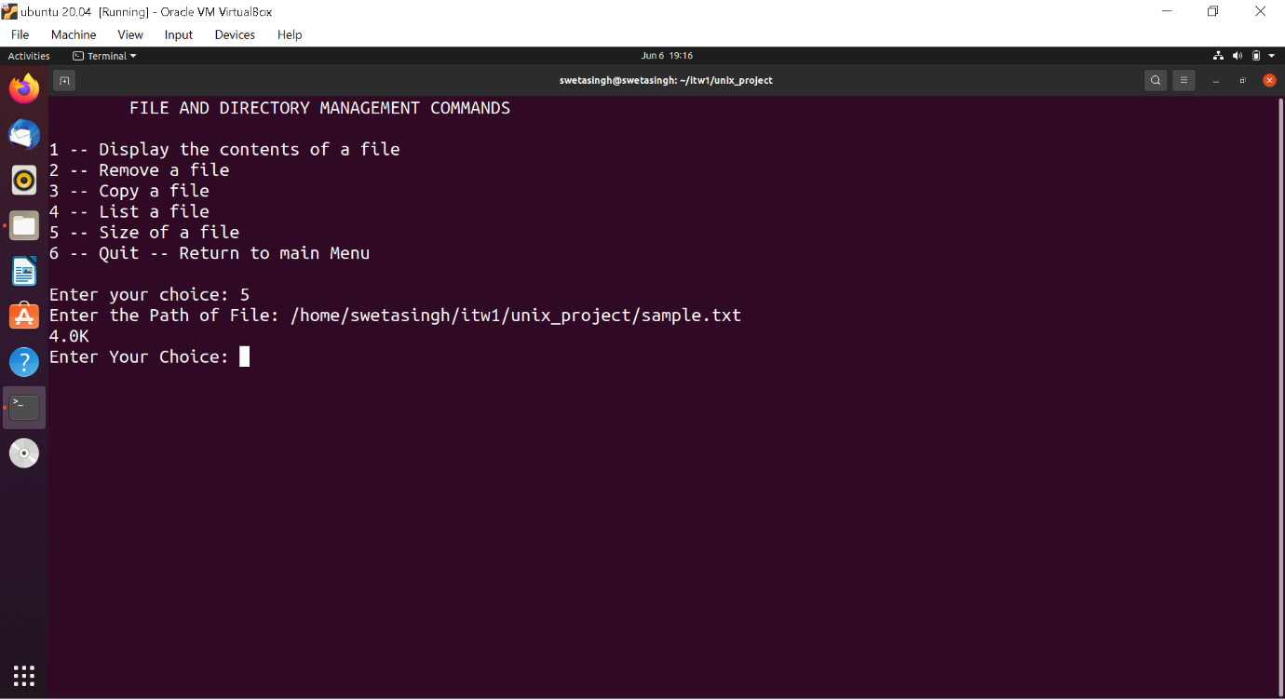

**2 – TEXT PROCESSING COMMANDS**

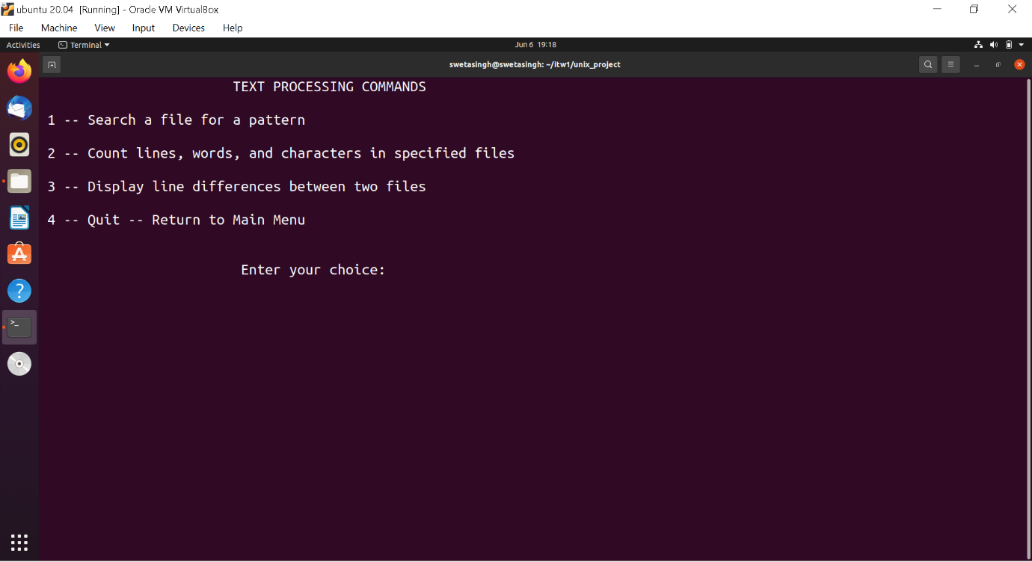

TEXT PROCESSING COMMANDS: 1 – Search a file for a pattern

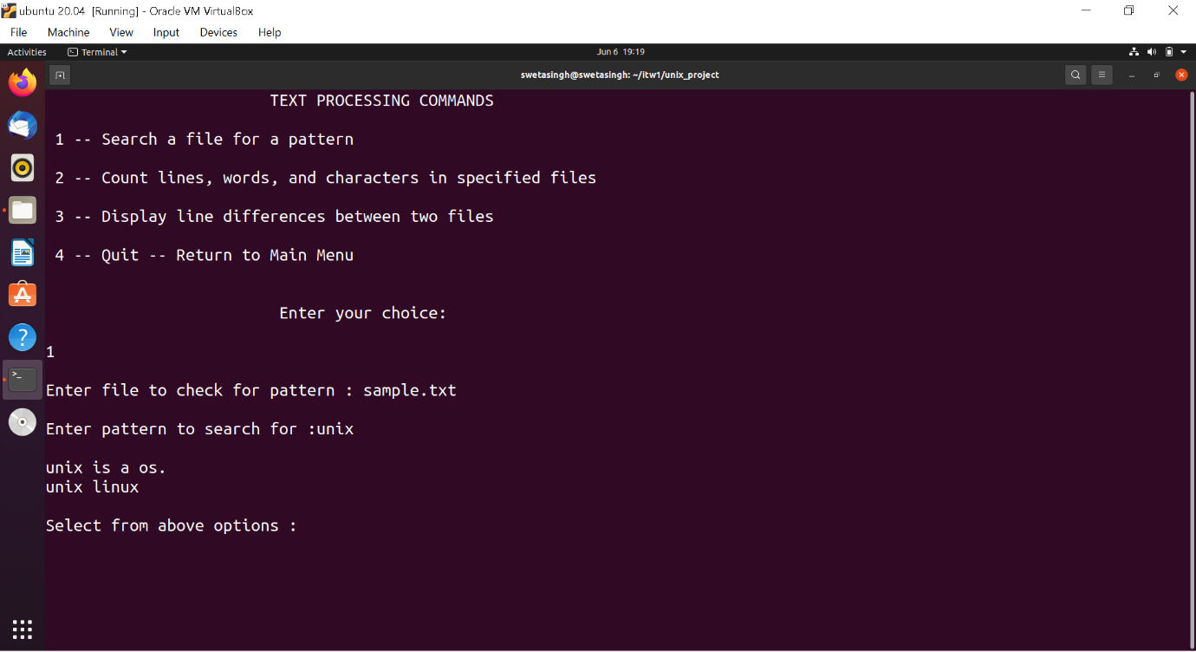

TEXT PROCESSING COMMANDS: 2 – Count lines, words and characters in a file.

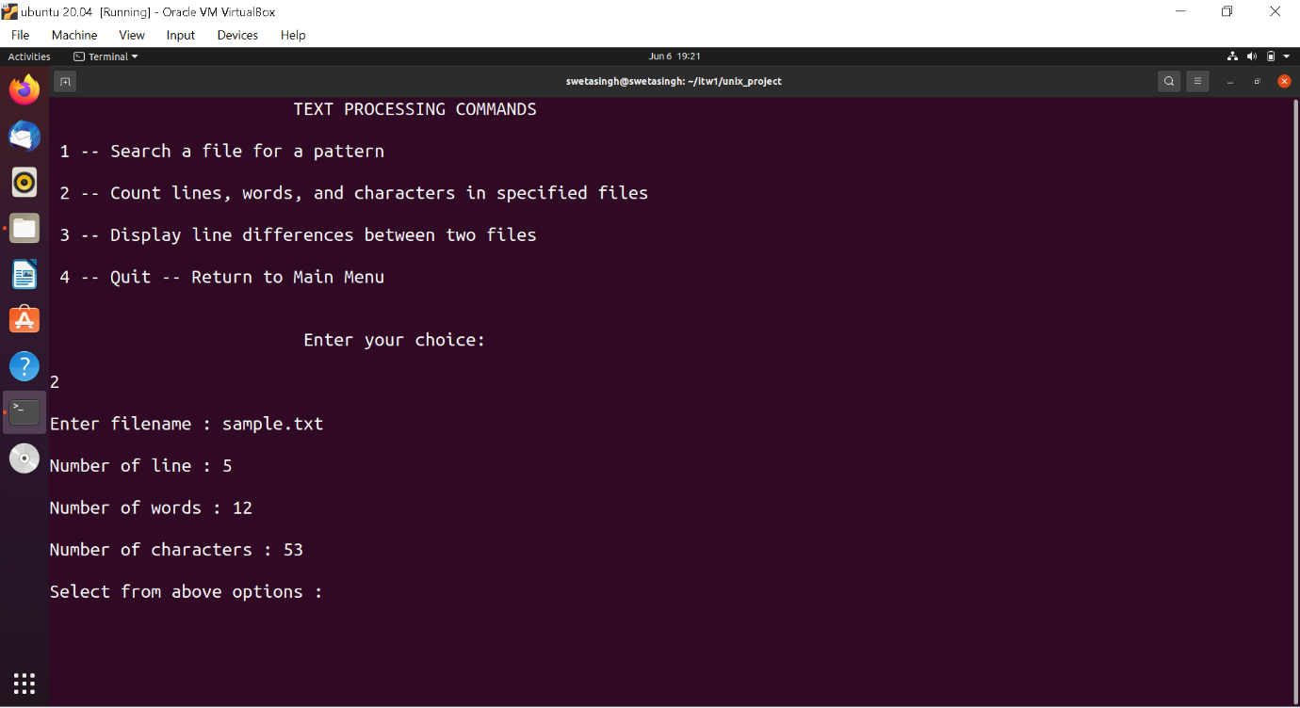

TEXT PROCESSING COMMANDS: 3 – Display line differences between two files

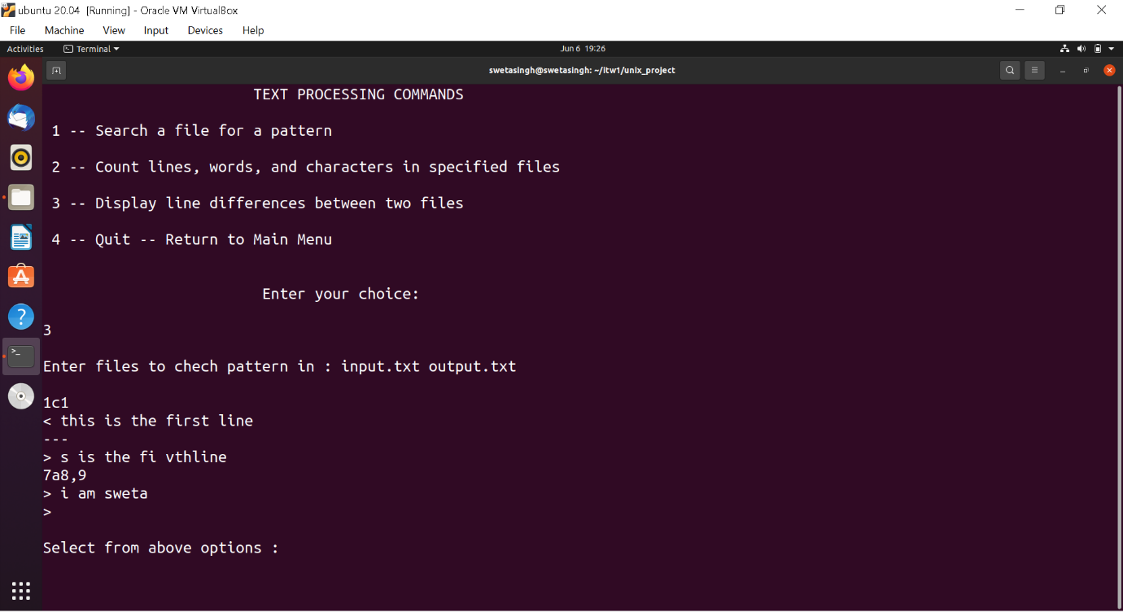

**3 – SYSTEM STATUS COMMANDS**

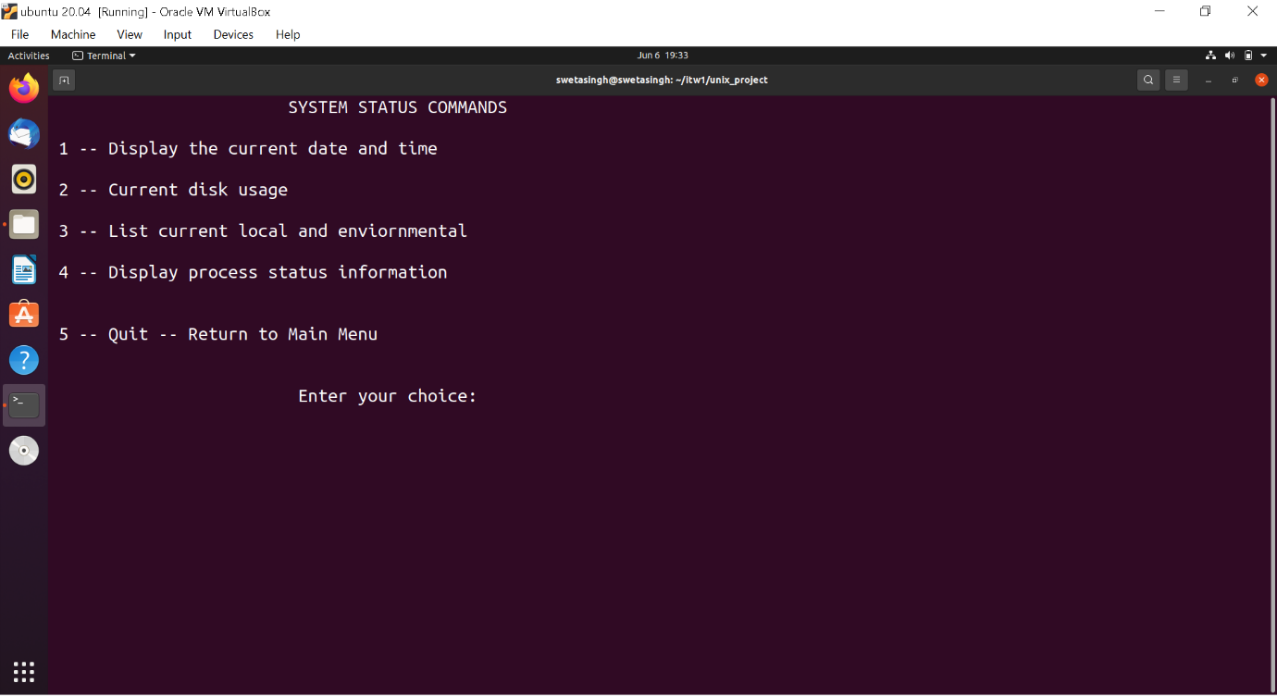

SYSTEM STATUS COMMANDS: 1 – Display current date and time

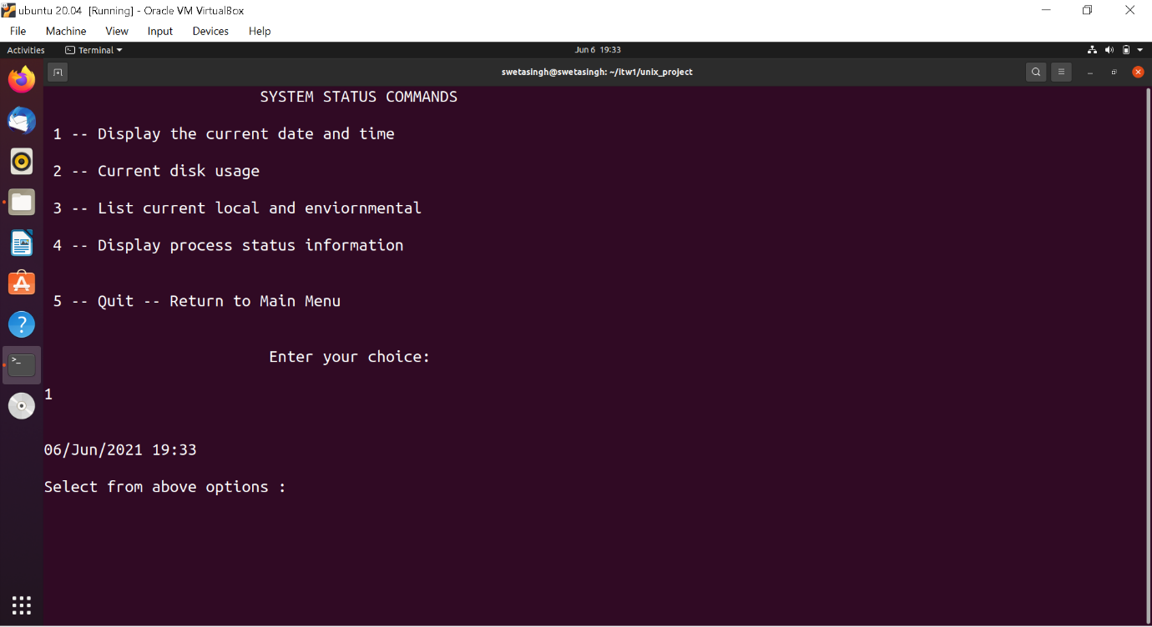

SYSTEM STATUS COMMANDS: 2 – Current disk usage

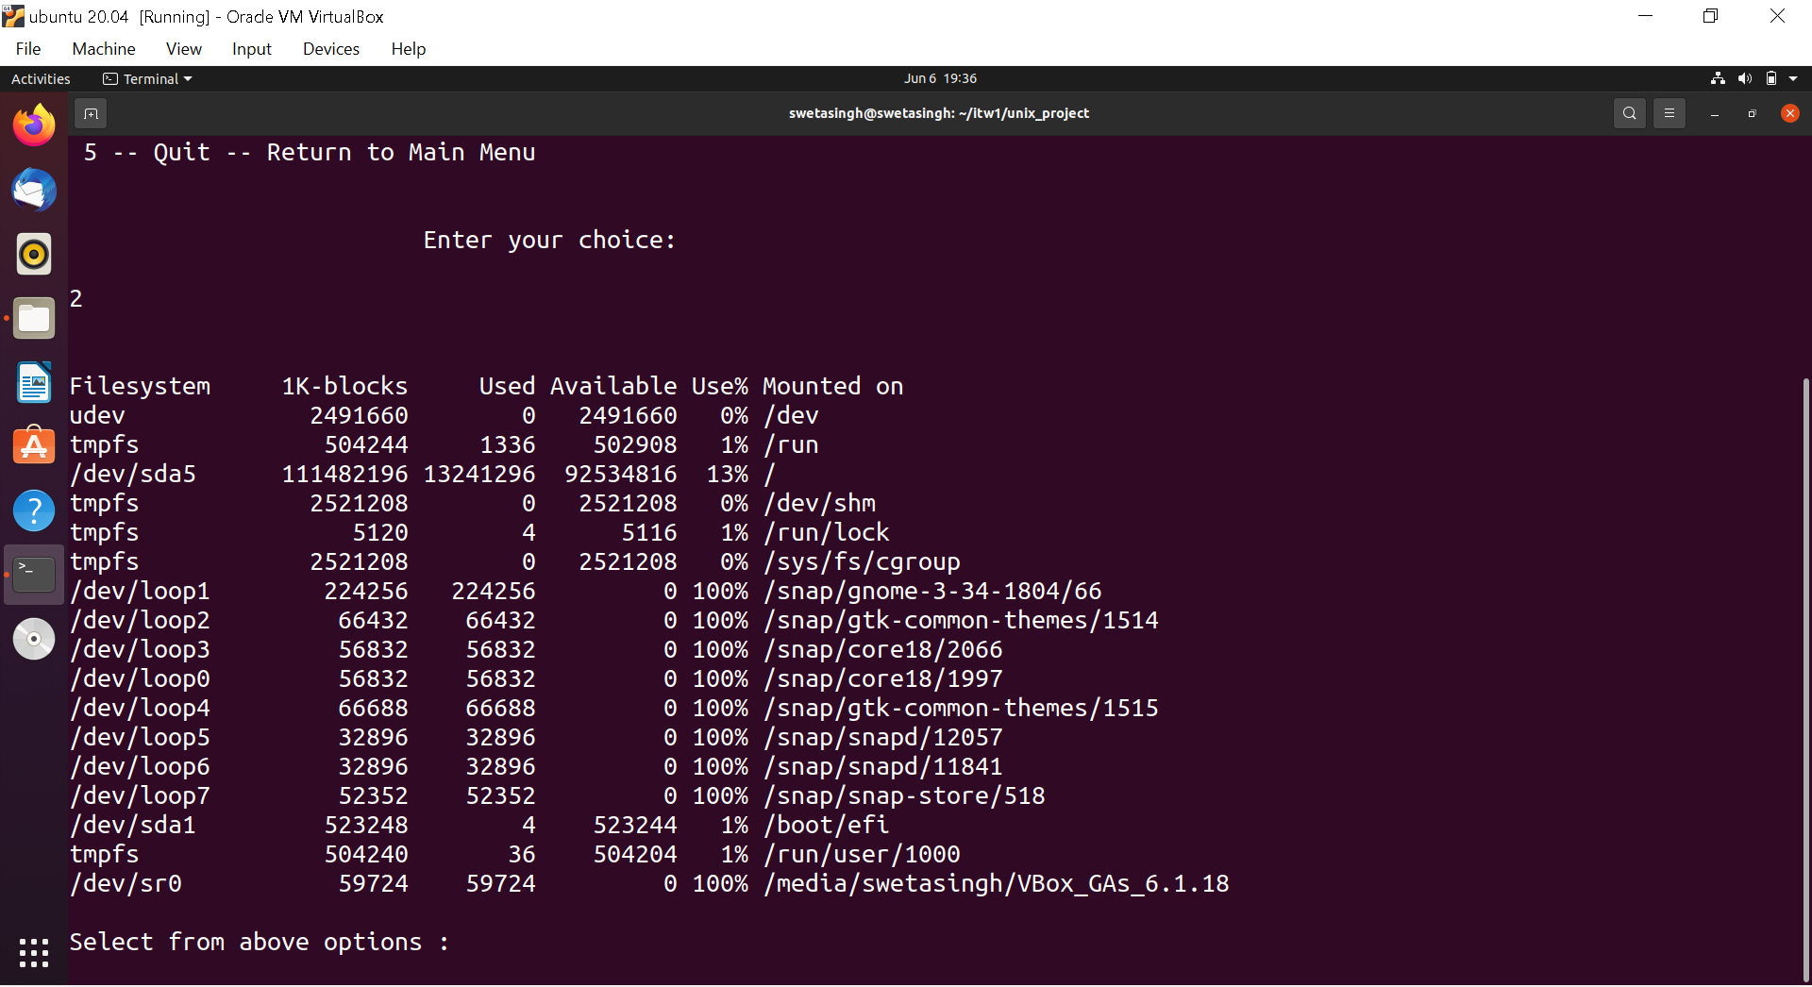

SYSTEM STATUS COMMANDS: 3 – List current local and environmental

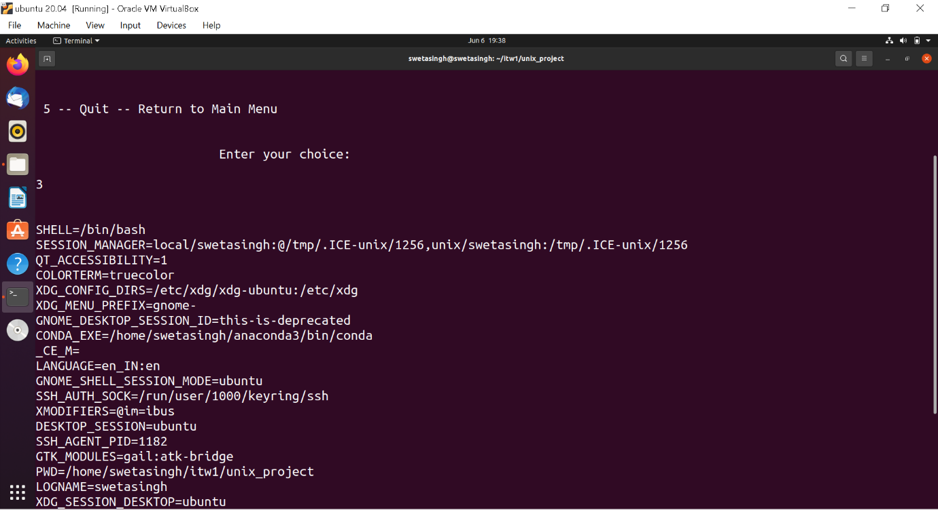

SYSTEM STATUS COMMANDS: 4 – Display Process status information

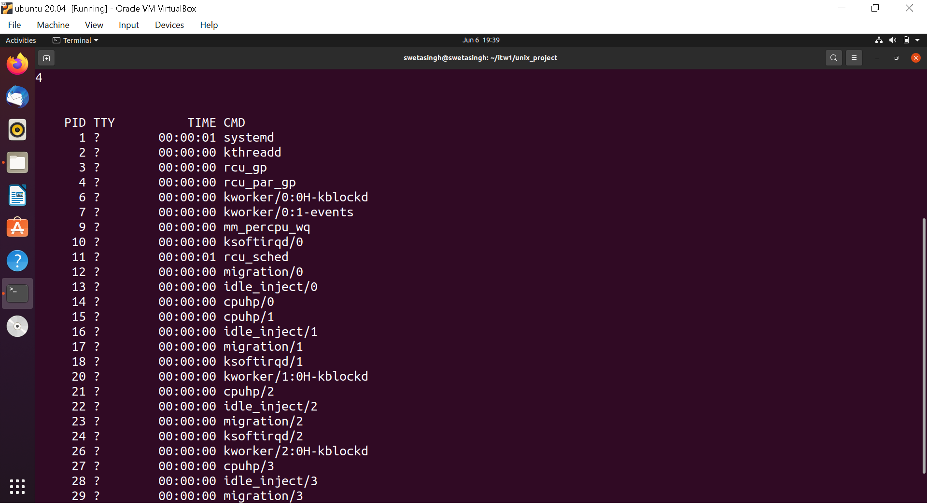

Exiting the program

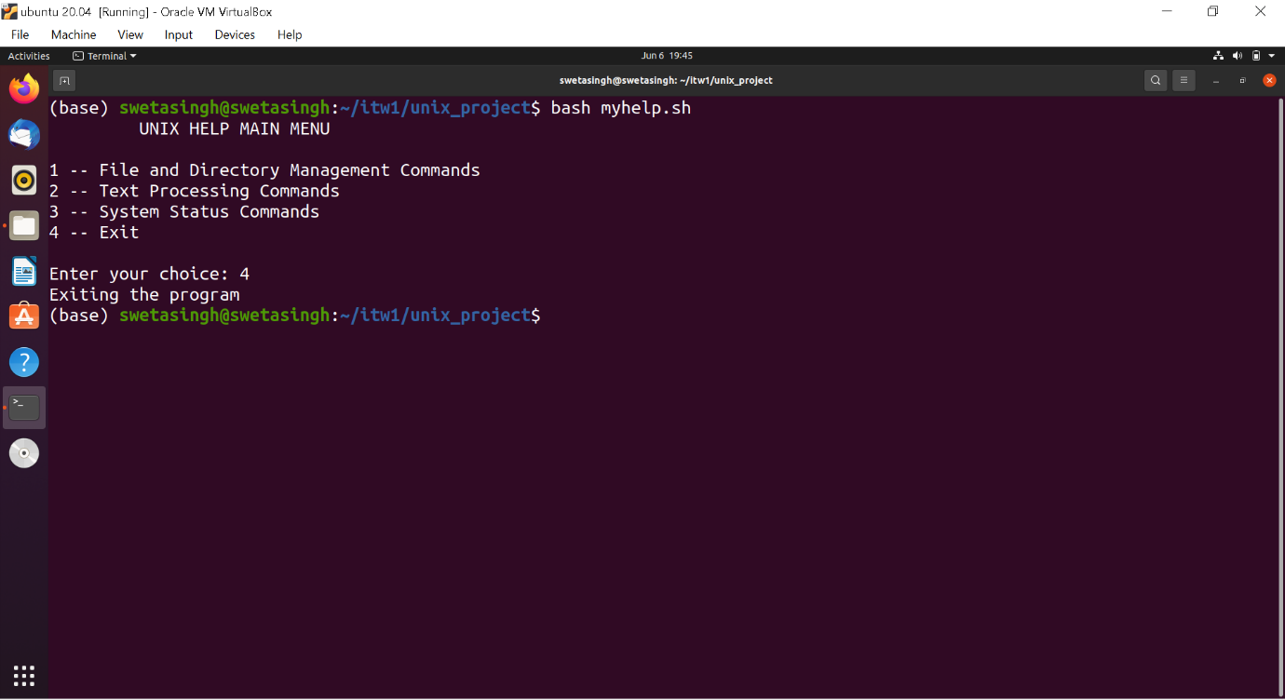

Error handling

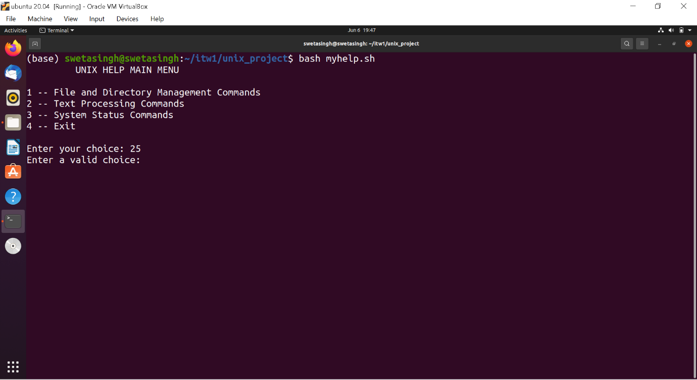

**Help Window**

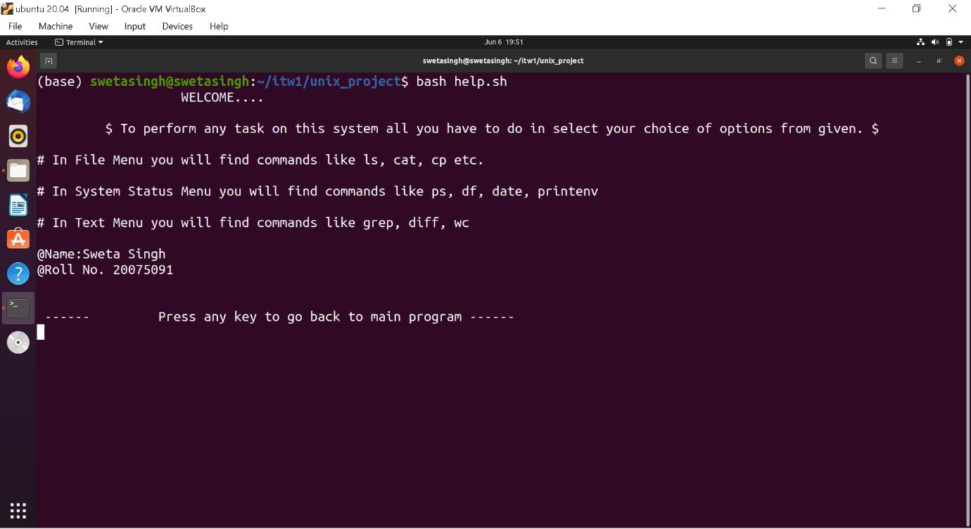

**FILE MENU in expert mode**

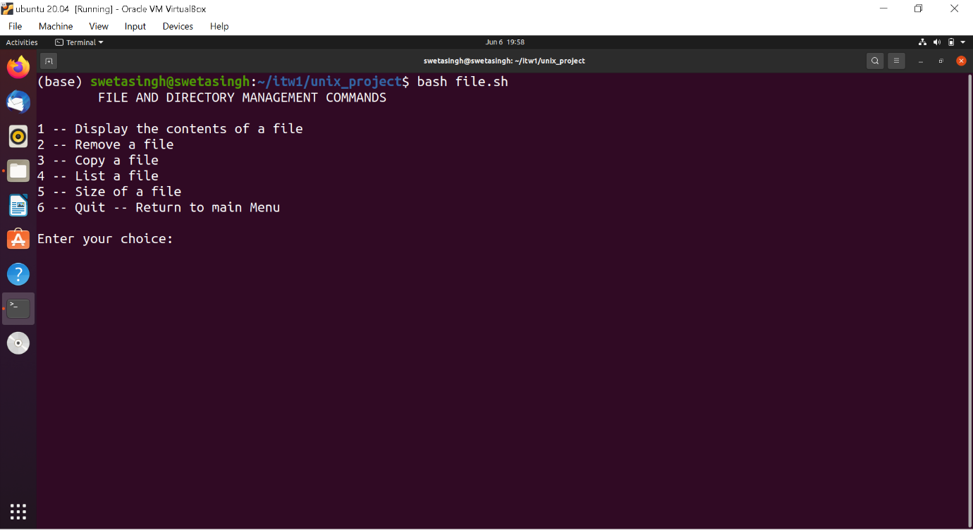

**TEXT MENU in expert mode**

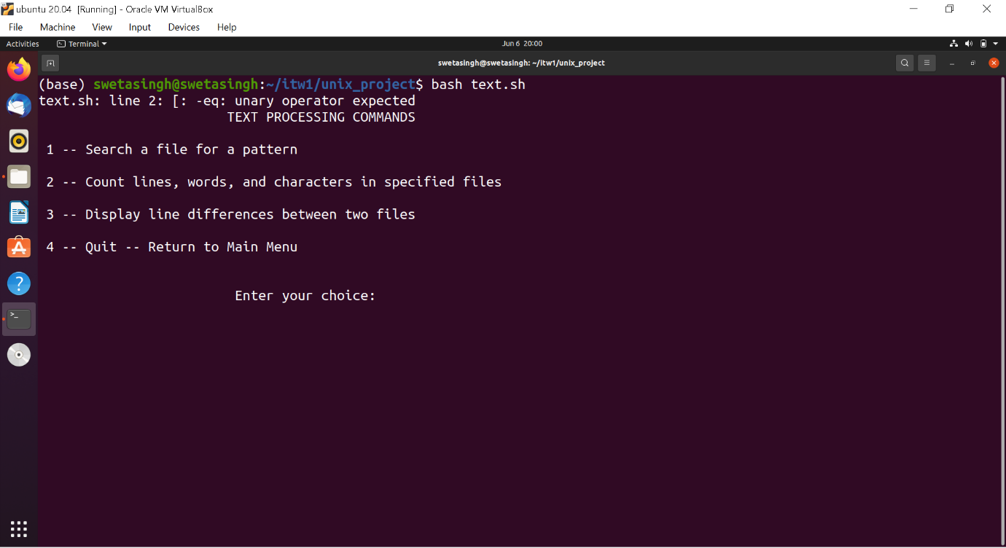

**SYSTEM MENU in expert mode**

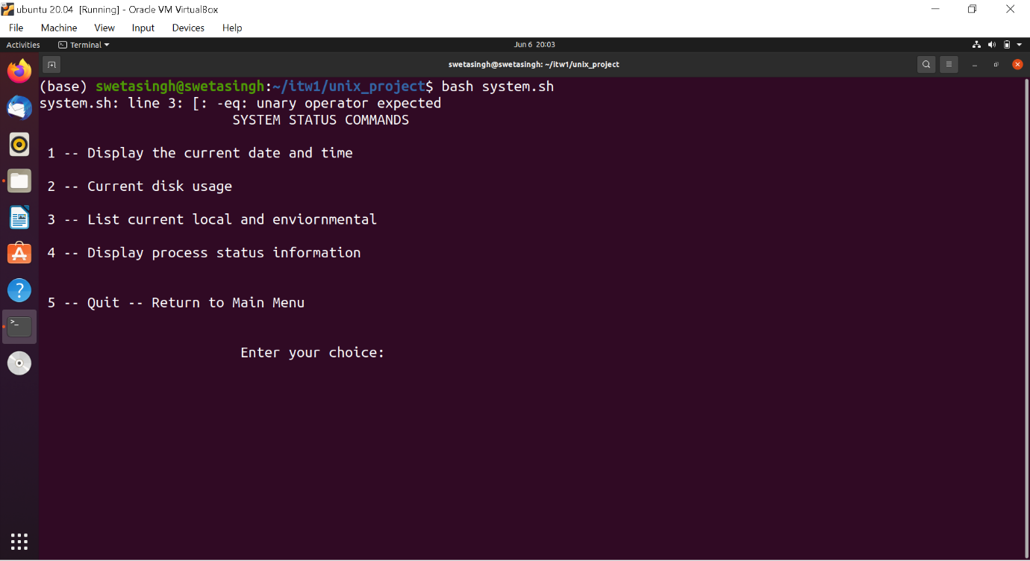

**Invalid argument handling**

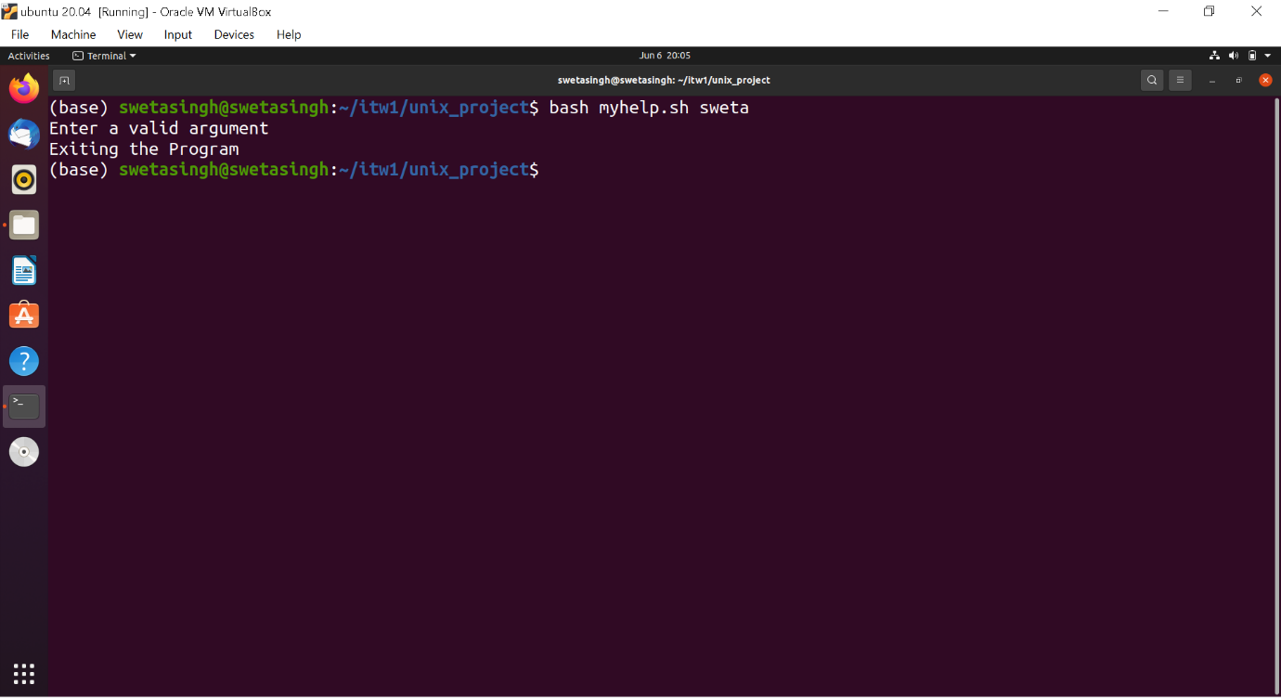

**---------------------------END------------------------------------------------------------------------------------------**